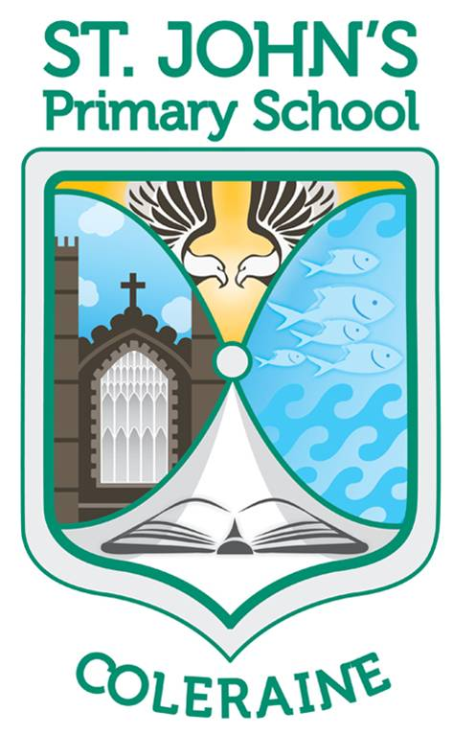St John’s Primary School

Hazelbank Road ● Coleraine ● BT51 3DX

Telephone: (028) 7034 4437

Principal: Mrs H McDonnell BA(Hons), PGCE, PQH(NI)

E-mail: [cburns390@c2kni.net](mailto:cburns390@c2kni.net)

[www.stjohnspscoleraine.com](http://www.stjohnspscoleraine.com) Twitter: @StJohnColeraine



Guidance for all visitors entering St. John’s P.S. during COVID-19

The following information and guidance is set out to help any visitors who need to work with pupils or meet staff members throughout the course of the day. This guidance is in place to protect all staff, visitors and children during this extraordinary time. It is the responsibility of the visitor to ensure that they have taken all possible precautions and that they comply with PHA guidance before entering the school premises.

On entering the school premises, visitors must:

* Use the hand sanitizer positioned at the front door.
* Sign in the visitor book indicating who they meeting.
* Leave a mobile phone number for potential contract and trace purposes.
* Wear a face covering whilst moving around the school corridors.
* Use a face visor when working closely with children on a one-to-one basis.
* Maintain social distancing where possible.
* Ensure adequate ventilation by opening windows (if not already done so)
* Sign out when finished.

We hope this guidance is informative and helpful and that you will still find St. John’s a warm and welcoming place to visit.

C. Burns September 2020