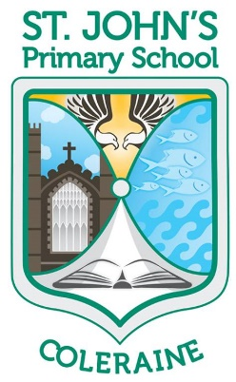St John’s Primary School

Hazelbank Road ● Coleraine ● BT51 3DX

Telephone: (028) 7034 4437

Principal: Mrs H McDonnell BA(Hons) PQH(NI) PGCE

E-mail: hmcdonnell187@c2kni.net

[www.stjohnspscoleraine.com](http://www.stjohnspscoleraine.com) Twitter: @StJohnColeraine



June 2020

Dear Parents

I hope that you and your families are well during this very challenging time. It is hard to believe that our school classrooms, playgrounds and corridors have remained silent and empty since mid-March. Normally at this time of year our school would be bustling with children excited about Sports’ Day, school trips, class parties and getting their summer holidays. COVID19 has ensured that our day to day life has been changed beyond recognition and we are all beginning to come to terms with our new ‘normal’.

The Department of Education has recently issued detailed guidance regarding the reopening of schools during August. We as a staff are working through this guidance and we are trying very hard to ensure we are in a position to open our school in a safe manner for our staff and your child/ren. I hope to be in a position soon to outline how St John’s will open. At the moment we know the new Year 7 class will commence school on Monday 24th August but, as you can appreciate, things have changed on a daily basis and may still change depending on the behaviour of the virus.

I want to take this opportunity to thank you as parents for being so understanding and flexible in this extremely difficult time. Your continued support of St John’s is very much appreciated by all our staff. I would also like to thank all our staff who have ensured the children have received work to complete remotely, enabling a level of continued learning to take place. We have had and continue to have staff working within the school on important maintenance work, administrative work and ensuring our school doors can reopen and your children can enjoy a bright and welcoming environment.

The introduction of Seesaw has been a fantastic resource and has allowed us all to experience blended learning, something we may have to get used to in the future. Seesaw has allowed your children to stay connected with their teachers and more importantly their classmates. The idea going forward will be to ensure every school child will become more confident using Seesaw and develop their use of this resource.

This week sees us saying goodbye to our year 7 class. Normally this would be a full school celebration so it is very sad that we are not having the opportunity to fully say goodbye to this class. The current Year 7 class is an exceptional class, individually very strong academically, athletically, artistically and musically but together as a class unit they are a fantastic bunch of young people and will be deeply missed by all at St John’s. All the staff wish these children every success in their new school and we hope they will continue to call in to see the staff in the years to come.

As I said earlier, we hope to be able to outline to you our plans for reopening as soon as possible to give you every opportunity to organise things, but in the meantime can we as a staff wish you and your family a safe and happy summer break.

Best wishes

Mr B.